**Proposal of the *GEWEX/GHP Cross-Cut Project*:**

**“Cold/Shoulder Season Precipitation Near 0°C”**

**Objective:** To improve our understanding of future changes in hazardous cold/shoulder season precipitation and storms, especially occurring near 0°C.

**Co-Proposers:**

Pavel Groisman – UCAR at NOAA National Climatic Data Center, USA and P.P. Shirshov Institute for Oceanology, Russia, [Pasha.Groisman@noaa.gov](mailto:Pasha.Groisman@noaa.gov)

Ronald Stewart - University of Manitoba, Canada [ronald.stewart@umanitoba.ca](mailto:ronald.stewart@umanitoba.ca)

**Research Team:**

**Canada:**

Robert Kochtubajda – Environment Canada, Edmonton, Alberta, [bob.kochtubajda@ec.gc.ca](mailto:bob.kochtubajda@ec.gc.ca)

John Pomeroy, University of Saskatchewan, [john.pomeroy@usask.ca](mailto:john.pomeroy@usask.ca)

Julie Theriault - University of Quebec at Montreal, [theriault.julie@uqam.ca](mailto:theriault.julie@uqam.ca)

**China:**

Pan Mao Zhai, Chinese Meteorological Administration, pmzhai@[cma.gov.cn](http://cma.gov.cn/)

**France:**

Olga Zolina, Le Laboratoire de glaciologie et géophysique de l'environnement (LGGE), [ozolina@lgge.obs.ujf-grenoble.fr](mailto:ozolina@lgge.obs.ujf-grenoble.fr)

**Japan**

Jun Matsumoto, Dept. of Geography, Tokyo Metropolitan University, [jun@center.tmu.ac.jp](mailto:jun@center.tmu.ac.jp)

**Norway:**

Inger Hanssen-Bauer, DMNI, [ingerhb@met.no](mailto:ingerhb@met.no)

**Russia:**

Olga Bulygina - Russian Inst. For Hydrometeorology, [bulygina@meteo.ru](mailto:bulygina@meteo.ru)

Sergey Gulev – RAS Institute for Oceanology, [gul@sail.msk.ru](mailto:gul@sail.msk.ru)

Tamara Shulgina - Institute of Monitoring of Climatic and Ecological Systems, Siberian Branch of Russian Academy of Sciences, [stm@scert.ru](mailto:stm@scert.ru)

**USA:**

Roy Rasmussen –National Center for Atmospheric Research (NCAR), [rasmus@ucar.edu](mailto:rasmus@ucar.edu)

Michael Squires – NOAA National Climatic Data Center [mike.squires@noaa.gov](mailto:mike.squires@noaa.gov)

Russell Vose – NOAA National Climatic Data Center, [russell.vose@noaa.gov](mailto:russell.vose@noaa.gov)

**1. Background**

Many regions of the world are subjected to precipitation occurring near 0°C during the cold and shoulder (spring/autumn) seasons (hereafter, near-0°C precipitation). Major snowstorms obviously occur but a wide variety of precipitation types (including freezing rain, freezing drizzle, ice pellets and wet snow) do as well. Several types often occur simultaneously and rain occurring on top of snow is a critical, related phenomena.

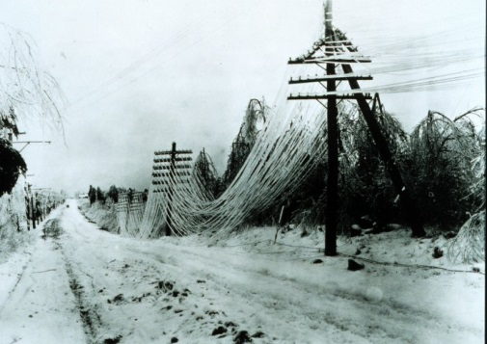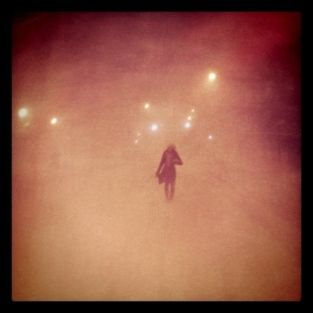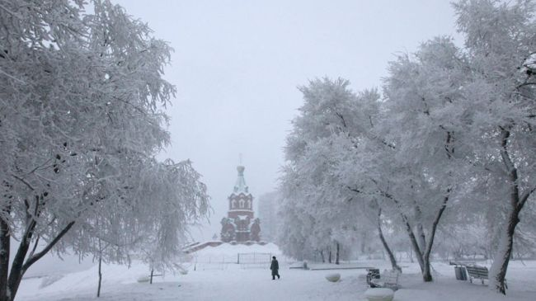

**Figure 1. Examples of near-0°C precipitation events and their consequences.**

Small changes in atmospheric conditions lead to major changes in the types or amount of near-0°C precipitation. For example, if near-surface temperatures are slightly above (below) 0°C, rain or wet snow (snow) occurs; if a slightly above-freezing inversion occurs (or not) aloft, freezing rain (snow) can reach the surface. It also needs to be recognized that solid precipitation amounts near 0°C (such as wet snow) can be the highest in a winter storm. Such temperatures represent the maximum water vapour holding capacity (saturated water vapour pressure) of the atmosphere with its value at 0˚C (6.1 hPa) being more than twice its -10˚C value (2.9 hPa).

There are many impacts of near-0°C precipitation. Heavy snowfall generates hazards for infrastructure and transportation. Wet snow and freezing rain may create hazardous traffic conditions and icing on communication lines (Changnon 2003), and they can have major effects on ecosystems and wildlife (Millward and Kraft 2004; Zhou et al. 2011). Rainfall on mountainous terrain covered by melting snowpack (rain-on-snow events) may initiate intense snowmelt with flash flooding (Groisman et al. 2003; McCabe et al. 2007).

Even when the total amount of near-0°C precipitation is not considered unusual, it can represent a natural hazard. For example, 25.4 mm of rainfall usually goes unnoticed as a hazardous weather event but, if the same precipitation falls as freezing rain, as wet snow, or as rain on a mountain snowpack, it may become a hazard-generating event. Houston and Changnon (2007) showed that freezing rain in the U.S. has the potential for a more severe societal impact than snowfall or rainfall for the same mass of precipitation.

Near-0°C precipitation affects large regions of the world. Higher latitude areas such as Russia, Fennoscandia, Canada and United States are particularly prone but, on occasion, lower latitude regions are as well. For example, an ice storm in 1998 (Henson et al., 2007) remained the most costly natural disaster affecting Canada until rain-on-snow enhanced 2013 flooding in Alberta. Eastern portions of North America suffered from such an event at Christmas 2013 with infrastructure losses in the billions of dollars, a number of fatalities, and inconvenience for millions of people. Shanghai suffered a devastating 2008 freezing rain event (Zhou et al., 2011). In Germany, Frick and Wernli (2012) pointed out the many consequences on infrastructure and transportation of a devastating 2005 wet snow event.

With global climate change in the extratropics, the 0°C isotherm will not disappear and associated precipitation events will continue to occur. Some studies have been conducted on recent trends in N0P and its parent storms in Europe (Førland and Hanssen-Bauer (2000; Zolina et al 2013) and North America (Mekis and Vincent 2011; Hanesiak and Wang 2005; Henson and Stewart 2007; Zhang et al 2012). Analyses of the frequency of winter extratropical cyclones over Eastern Europe (Partasenok et al. 2014) show that, while their number is decreasing, their intensity (atmospheric central pressure) is strengthening which increases the possibility of more intense precipitation and stronger winds. Farther eastward over the Russian Federation (east of 40°E), higher amounts of maximum snow water equivalent in the snowpack (Bulygina et al. 2011) also suggest intensification of infrequent snowfalls. It is worth to note that over oceans as well as along the coastal regions of North America the cold season storminess has been increased (Wang et al. 2012; Vose et al. 2014).

Given overall warming, patterns of winter precipitation are expected to continue changing. Rain should fall farther upslope in mountainous regions, thereby increasing the risk of flooding. Alterations in temperatures, storm intensity and track will alter the likelihood and occurrence of N0P including freezing rain (e.g. Lambert and Hansen 2011). Weakening of the atmospheric circulation in the extratropical regions (e.g., Tilinina et al. 2013; Wang et al. 2012) may lead to more polar jet stream meandering (e.g., Francis and Vavrus 2012) that can lead to more persistent near 0°C events. The overall warming, together with a larger influx of the water vapour in the winter atmosphere from the oceans (including ice-free portions of the Arctic Ocean) will allow more water vapour in the winter atmosphere that can increase the amount of N0P. And, near 0°C temperatures should generally move poleward and arrive at many locations earlier in spring or later in autumn. This could potentially affect the seasonal cycle of near-0°C precipitation. It may increase the duration of near-0°C conditions in the first half of the year and what we term 'transition from winter to spring' periods when this precipitation occurs, and it may also be associated with swifter shifts  from autumn to winter which may potentially lead to a greater number of severe near-0°C precipitation events.

Despite significant progress in addressing near-0°C precipitation, it remains a challenging issue. Kunkel et al. (2013) indicated that freezing precipitation was associated with the lowest level of understanding for both detection and attribution amongst several types of hazardous weather conditions affecting the U.S. Some of this uncertainty stems from the difficulty of accurate measurement of key variables. It is difficult to measure some forms of cold season precipitation including their combinations. Also, we are not aware of any articles which have developed a global climatology of, say, freezing rain. There have been regional studies for North America (e.g., Changnon 2002, 2003; Changnon and Bigley 2005; Cortinas et al. 2004) and Europe (e.g., Carriere et al. 2000) but these studies have not been brought together and combined with information over other regions. The general large scale precursors for the occurrence of these hazardous conditions are somewhat known in that, for example, warm frontal circulations during the cold season may commonly lead to freezing rain but there are still fundamental issues linked with detailed processes. This includes the precise manner through which hazardous precipitation arises including the conditions leading to ice nucleation that is often critical as to whether freezing drizzle will occur or not. It is crucial to have a good sense of the physical processes before one can increase confidence in future projections.

**2. Rationale**

Cold/shoulder season precipitation near 0°C is of interest to several components of GEWEX. It is certainly an important issue in some of GHP’s (GEWEX Hydroclimatology Panel) regional projects such as CCRN (Changing Cold Regions Network) over western Canada, Baltic Earth and NEESPI (Northern Eurasian Earth Science Partnership Initiative). Such precipitation is also important for GDAP (GEWEX Data and Applications Panel) as it seeks to characterize precipitation globally, including its phase.

Cold/shoulder season precipitation issues have justifiably been recognized by GEWEX in its Science Questions. One of the activities identified in Science Question 4 (Extremes) is to examine “cold season extremes such as snowstorms, rain-on-snow episodes, freezing precipitation”. Such an activity is undoubtedly of interest to CliC and is within the scope of the WCRP Grand Challenge on Extremes that is being developed.

**3. Objective**

Given the importance of this issue and its contributions to GEWEX and WCRP, it is proposed that a GHP cross-cut be developed to **improve our understanding of future changes in hazardous cold/shoulder season precipitation, especially occurring near 0°C.**

This requires understanding past and present changes and as well as considering future conditions. Addressing these requires an examination of several issues including data requirements and availability, climatology of key variables and phenomena, simulation and understanding of key driving processes, and assessment of projections and their shortcomings. Assessing the current situation in these various categories will undoubtedly lead to the identification of specific gaps.

Studies of near-0°C precipitation cannot focus only on projections of changes in its duration, timing, intensity, and frequency. These studies should also include assessments of their impact. The researchers have to evaluate and quantify the inconveniences associated with near-0°C precipitation and reveal as accurate as possible each hazard associated with the inclement weather events, quantify it, develop the mitigation measures, and project the future of these events in their interactions with societal response.

**4. Ongoing and further studies**

With precipitation falling at surface air temperature near 0°C, the It is a human perception when the unpleasant weather becomes hazardous. Generally speaking, the difference is in the event intensity characterized by the thresholds when different sectors of human activities begin to feel its disruptive impact. Therefore, some criteria can be suggested based on (a) property losses (e.g., fallen trees and power lines, damaged buildings, bridges, pipelines, and vehicles), (b) losses of opportunities to conduct business as usual (e.g., transport delays, crop and livestock losses), and (c) danger to human health and life (e.g., fallen icicles, road ice accidents, building collapses, ship capsizing, and technogenic catastrophes, to mention a few).

There are at least two broad perspectives to be considered in relation with precipitation near 0°C. First, one must consider the actual impact. As summarized in the Introduction, this includes numerous issues including icing, visibility, etc. Some of these are somewhat ‘everyday’ in terms of consequences whereas others (such as major freezing rain storms) can be catastrophic. What are the thresholds for the various impacts?

The second perspective is the physical phenomenon itself. One can consider three broad categories of N0P events: blizzard (just snow), rain on snow (both phases with a particularly importance of the precipitation interaction with pre-existed snowpack), and freezing rain and drizzle. The specific hazards associated with these events include:

* 1. **Heavy snowfall/rainfall transition around °C**

In the cold weather (when surface air temperatures are less than 1°C) precipitation, P, occurs more frequently in the days when surface air temperature is near 0°C and, because of the larger water holding capacity of the atmosphere compared to the days with colder temperatures, the amount of this precipitation is also higher. For example, when we selected all six-and 12-hourly observations with corresponding P totals above 3 mm (above 10 mm) over 517 Russian stations in the cold weather during the past five decades, we counted around 62, 000 (8,600) observations for temperatures in the interval [0°C, 1°C] and 35,500 (4,300) observations for temperatures in the interval [-1°C, 0°C] that comprise one third of all precipitation values above 3 mm or 35% of their totals and 45% of precipitation values above 10 mm or 42.5% of their totals.

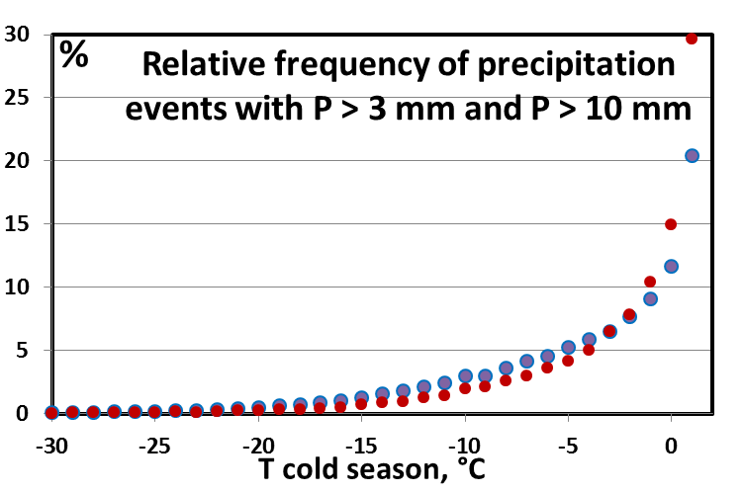

**Figure 1. Frequency (% of the total number) of precipitation events above 3 mm (blue dots) and above 10 mm (red dots) in the cold season as function of long-term mean cold season temperatures for the days with reported precipitation, P, above 3 mm and 10 mm respectively. This analysis is based upon Archive “Sroki” with synoptic information for the 1966-2013 period at the 517 Russian synoptic stations (**[**http://meteo.ru/data/163-basic-parameters**](http://meteo.ru/data/163-basic-parameters)**).**

Figure 1 presents the relative frequency (in %) of noticeable precipitation events (above 3 mm and 10 mm) during the cold season for the same set of stations and analysed period sorted by the temperatures at the time of events. This figure shows that, while the cold season precipitation may occur at quit low temperatures, most of them (especially those with substantial total amount of precipitation, e.g., above 10 mm per observation) are observed at warmer cold season temperatures that are close to 0°C. Part of this precipitation was liquid (cold rainfall) and transition between its two phases (liquid / frozen) may occur with a small variation of weather conditions (e.g., of near-surface air temperatures). This transitions occur with nearly half of heavy cold season precipitation (at least, in Russia) and may represent numerous hazards impacting infrastructure (e.g., roof load by snowpack and ice) and transportation (e.g., icy roads). When heavy snowfall is followed by rainfall, the liquid precipitation does not flow away but accumulates in the wet snowpack, changes its structure, and forms ice on the top of the ground. In montane terrain, the wet snowpack is frequently a prerequisite for flash floods (cf. **4.3**).

* 1. **Blizzards**

Blizzards occur in the days with snowfall accompanied with strong winds. The presence of snow on the ground, especially of light non-compressed dry snow may serve an additional source for blizzards when blowing snow is raised from the surface into the air. Blizzards may occur in the middle of the winter as well as in the shoulder seasons. They are associated with atmospheric cyclones passing the region and, when strong, represent natural hazard that interrupt human activities (e.g., transportation). Cyclone passages in the cold season are associated with substantial surface air temperature increase in high latitudes (Groisman et al. 1996). For example, while mean cold season temperature averaged for the past fifty years over the entire cold season (when temperature is below 1°C) at 517 first-order Russian stations is – 12.2°C, the same temperature values when non-zero (3 mm or more) precipitation, P, are reported is two (seven) degrees warmer: -10.0°C and –4.9°C respectively (Figure 2). Furthermore, when at the same time non-zero (> 3 mm) P is accompanied by the near-surface wind that exceeds 5 m s-1 (“blizzard weather conditions”), temperatures become warmer by 4.5°C reaching -7.7°C (by 6.8°C reaching -5.4°C) respectively. Our analyses show that about 40% of blizzards over Russia with precipitation above 10 mm occur when surface air temperatures associated with the blizzard is in the 1°C vicinity of 0°C.

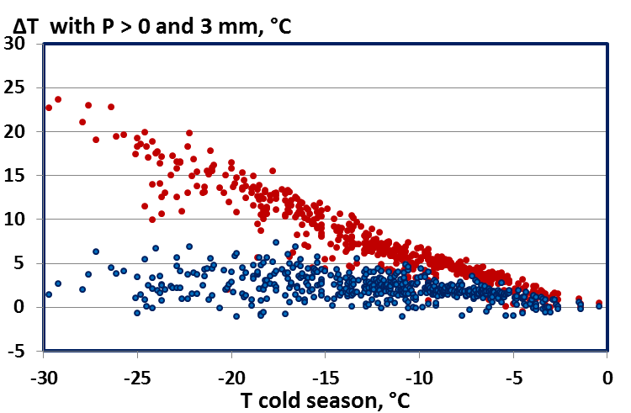

**Figure 2. Mean surface air temperature deviations during precipitation (ΔTwith P) from long-term mean cold season temperature values, T, plotted versus T for the days with non-zero precipitation, P (blue dots) and for the days with reported precipitation, P, above 3 mm. Each dot represents a single station mean value averaged for the 1966-2013 period.**

**The relative frequency distribution of blizzard events has the same shape. The same set of stations and period of averaging as in Figure 1.**

* 1. **Rain-on-snow events**

Rain falling on snow causes more rapid snowmelt and, when the rainfall is intense, this may result in flash flooding. Along the western coast of North America rain-on-snow events are the major cause of severe flash floods. Figure 3 show the frequencies of the rain-on-snow events over northern North America and Russia and their changes during the past fifty years. At this stage, a formal criterion was used to define these events: number of days with rainfall ≥ 1 mm when snow depth is ≥ 3 cm without accounting for ripening of the snowpack. Left panel in Figure 3 shows a significant increase in the frequency of rain-on-snow events (*as defined above*) in winter over western Russia (by 50% per 50 years) and a significant reduction of similar size over western Canada. In spring, there is a significant increase of rain-on-snow events over Russia (mostly over its western part), but there is also a significant decrease of the frequency of these events in the western Canada. This decrease is mostly due to snow cover retreat.



**Figure 3. Rain on snow climatology and regional changes (Archive of ACIA 2005; Groisman et al. 2003)**

The above pilot analysis was made initially for the Arctic Climate Impact Assessment (ACIA 2005). However, not every rain-on-snow event represents a peril. The ACIA analyses should be revisited with a thorough attention to factors that were initially left beyond its scope: state (“ripening”) of the snowpack prior to the rain-on-snow event and the rain intensity.

* 1. **Intense ice and freezing rains**

Changnon (2002) developed a climatology of large-scale catastrophic ice and freezing rain events for the conterminous United States for the 1949-2000 period and quantified direct property losses (using insurance claims expressed in year 2000 dollar values) with the largest historical loss of $1.2billion per five days, from January 29 to February.2, 1951, as a combined impact of heavy freezing rain and high winds over the northeastern, central, and southern states of the country. Henson et al. (2011), for example, pointed out that a freezing rain storm in eastern Canada was one of Canada’s most costly natural disasters. National archives of each country affected by such events preserve history of largest events but they were never put together and/or analyzed in a joint fashion. For this proposal, we have not performed additional analyses of intense ice and freezing rain events, their climatology and tendencies.

* 1. **Impact of changes of maximum ice load on communication lines, roofs, and other man-made infrastructure**.

With global warming, more water can be held by the atmosphere. It may manifest itself by increasingly intense precipitation as it is seen across the entire extratropics (Trenberth et al. 2007; Groisman et al. 2013). However, if we consider the regions and seasons with surface air temperatures close to 0°C, this way of thinking does not work because the temperatures there are “fixed”. Only over those regions with such fixed temperatures where precipitation is caused by advection from warmer areas, e.g., from the Ocean, we can expect higher air mass humidity at the same near-zero °C temperatures. A brief look through climatic changes in the cold and shoulder season in the extratropics, analyses shown in Figure 4 as well as a general increase in the water-holding capacity of the atmosphere in the maritime[1] regions of the continents hints that we can expect:

* substantial shifts of the occurrences of intense ice and freezing rain events (geographically and within the seasonal cycle) and
* increasing occurrence of intense fraction of these rains.

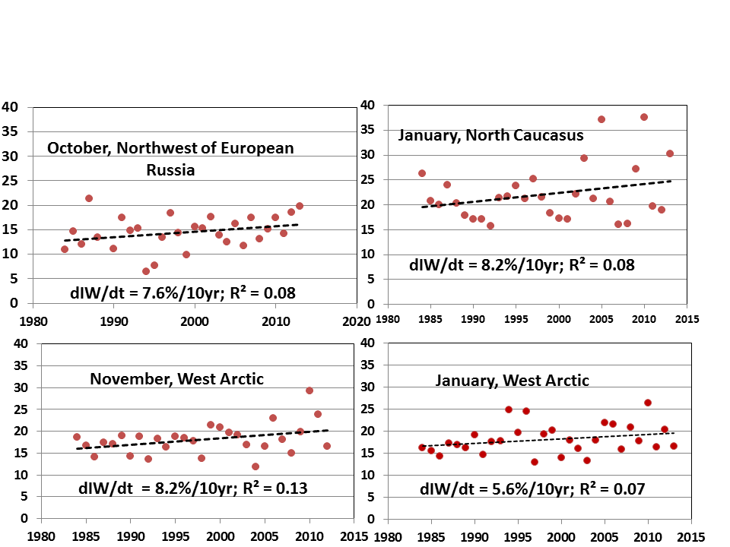

**Figure 4. Dynamics of the monthly maximum icing weight (IW) area-averaged over meteorological stations of northernmost and southernmost regions of European Russia (Bulygina et al. 2014).**

Recently, Bulygina et al. (2014) used the Russian “Atmospheric Events” archive for the past 30 years to show a significant increase in the maximum icing quantities over the three Western Russia regions adjacent to the Barents, Baltic and Black Seas (Figure 4). Here they make use of the unique quantitative observations of icing weight observations conducted at the Russian Meteorological network. These icing events can occur during intense ice and freezing rains as well as during freezing drizzles. Therefore, both require our attention.

Arctic sea ice retreat in the end of the warm season (Fetterer et al. 2002 updated) and significant regional warming (SWIPA 2012) resulted in statistically significant increase in the dangerous maximum icing load in the Russian West Arctic where it may impact the trawler fleets and off-shore oil and gas platforms being built (or being planned to build) across the Barents and Kara Seas. Generally, such changes can be expected in all “humid” Arctic regions with significant open sea areas that are more and more experiencing regional warming. Further studies are needed in order to properly quantify this development potentially hazardous for human activity in High Seas.

**5. Proposed Tasks**

Events associated with near-0°C precipitation are not necessarily always ‘extreme’ but they do represent natural hazards. Moreover, these events will not wane with global warming but some may became more intense and their temporal and spatial patterns are expected to shift. However, many uncertainties remain and further in-depth studies are warranted. Therefore, we propose to:

**Task 1.** Prepare a review article for the Bulletin of the American Meteorological Society. Its objective will be to assess our current understanding of near-0°C precipitation, its trends and future occurrence and it will also highlight key scientific uncertainties related to it. It will utilize selected examples of phenomena and impacts from several different countries.

A number of other tasks are being considered after this review is completed or as it is in progress. Initial ideas include the following.

**Task 2**. Compile the metadata for each large national and international archive that has synoptic information relevant to the near 0°C precipitation; these include (in addition to coordinates, elevation, surrounding land cover type) a suite of observing practices and instrumentation specific to the country, region, and station type and develop algorithms of accurate precipitation quantification during the near-0°C precipitation events.

**Task 3.** Using contemporary reanalyses and RCM simulations, study the physics of atmospheric processes that can be potentially associated with near-0°C precipitation events such as

* extratropical cyclone trajectories, their intensity, temperatures anomalies, and water vapor transport along these trajectories
* land surface conditions preceding the cyclone arrivals (surface temperature, snowpack accumulation and its state )

and develop regional impact criteria of near-0°C precipitation events:

* intensity thresholds (if any) when each type of near-0°C precipitation events begin representing specific hazards (e.g. the Beaufort Wind Scale)
* composite weather conditions with high probability of flood (for rain-on-snow events in mountainous terrain), man-made infrastructure and vessels damages, and subsistence hazards for (a) wild life and (b) humans.

**Task 4**. Create contemporary climatology of each type of N0P events (since the major shift in the Earth system in the mid-1980s) and compare them with previous climatologies prepared in the past (e.g., those documented in the Reference Books on Climate in Canada, former USSR, and the United States) to evaluate empirically the dynamics of changes in these events frequency and intensity.

We shall use the presently existing archives of synoptic information for the extratropics accumulated in the national (e.g., Archives “Sroki” and “Atmospheric Events” delivered synoptic information for the Russian Federation at <http://meteo.ru/data>) and World Data Centers for Hydrometeorological Information (e.g., Integrated Surface Database distributed by the NOAA National Climatic Data Center (<http://www.ncdc.noaa.gov/data-access/land-based-station-data/land-based-datasets/integrated-surface-database-isd>) ). For the weather events not associated with hazards we shall update the climatologies of near 0°C precipitation events, identify the latest tendencies of changes in their intensity, frequency and distribution within the annual cycle., For the near-0°C precipitation events associated with specific hazards, each hazard will be assessed separately.

**Task 5.** Merge (establish coherence/relationship/linkages) observed changes in characteristics of N0P events (in particular, the hazardous near-0°C precipitation events) with physical processes that define them. Using these relationships and the credible GCM projections (e.g., CMIP5), we shall perform projections of future characteristics of these near-0°C precipitation events and their impact on societal activity and well-being.

**Task 6.** Improve the model representation of near-0°C precipitation. A substantial issue for this precipitation is that its driving mechanisms are complex and small changes in environmental factors can tip the precipitation from one type to another with large consequences. The assumptions and parameterizations in current models need to be assessed and recommendations made for their improvement.

**6. Timing**

This proposal will be presented at the upcoming GHP meeting in December, 2014 in Pasadena. It is hoped that the effort will be formally endorsed as a cross-cut activity at that meeting.

The proposed BAMS review article has just been started. The initial task will be to write a proposal to BAMS to approve the concept. This should be done by January 2015 and a good draft should be completed by July 2015.

No formal meeting of the whole group is currently planned. Informal meetings will occur at other workshops and conferences, e.g., the Annual AGU Meeting (December 2014) and Annual EGU Assembly (Vienna, April 2015). Prior to November 30, 2014, we shall propose a dedicated Parallel Session on the Cross-Cut Topic at the International Science Conference “Our Common Future under Climate Change”, July 2015, Paris, France <http://www.commonfuture-paris2015.org/> and will investigate an opportunity to use this venue for a topical side event. Much of the interaction will be through e-mails and conference calls.

**7. References**

Arctic Climate Impact Assessment (ACIA), 2005: Chapter 2 “*Arctic Climate System and its Global Role*” In: Arctic Climate Impact Assessment, “Impact of a Warming Arctic”, Cambridge University Press, 144 pp.

Atmospheric Environment Service, 1988: MANPUB: Manual of Standard Procedures .for Public Weather Service, 5th ed., Environ. Can., Downsview, Ontario.

Bulygina, O.N., P.Ya. Groisman, V.N. Razuvaev, and N.N. Korshunova, 2011: Changes in snow cover characteristics over Northern Eurasia since 1966. *Environ. Res. Lett*., **6**, 045204, [doi:10.1088/1748-9326/6/4/045204](http://dx.doi.org/10.1088/1748-9326/6/4/045204) (10pp)

Bulygina, O.N., N.N. Korshunova, and V.N. Razuvaev *,* 2013: Changes of the near-surface wind speed in Russia during the past decades. Transactions of the Main Geophys. Observ., **568.** 156–172 [available at: <http://voeikovmgo.ru/images/stories/publications/568.pdf>].

Bulygina, O,N., N. M. Arzhanova, and P.Ya. Groisman, 2014: Icing Conditions over Northern Eurasia in Changing Climate. *Environ. Res. Lett*. (in review).

Callaghan, T.V., M. Johansson, R.D. Brown, P.Ya. Groisman, N. Labba, V. Radionov and Co-Authors, 2011: The changing face of Arctic snow cover: A synthesis of observed and projected changes. *Ambio,*  **40***,* Suppl. 1, 17-31.

Carriere, J.M., C. Lainard, C. Le Bot, and F. Robart, 2000: A climatological study of surface freezing precipitation in Europe. *Meteorol. Applications*, **7**, 229-238.

Changnon, S.A., 2002: Long-Term Data Sets about Freezing Rains and Ice Storms in the United States. CD-ROM prepared as part of: Award Number NA16GP1585. The Office of Global Programs, National Oceanic and Atmospheric Administration, U.S. Dept. of Commerce

Changnon, S.A., 2003: Characteristics of ice storms in the United States. *J. Appl. Meteorol*., **42**, 630–639. doi: [http://dx.doi.org/10.1175/1520-0450(2003)042<0630:COISIT>2.0.CO;2](http://dx.doi.org/10.1175/1520-0450(2003)042%3c0630:COISIT%3e2.0.CO;2)

Changnon, D. and R. Bigley, 2005: Fluctuations in US freezing rain days. *Bull.Amer. Meteorol. Soc*., **77**, 1497-1506.

Cortinas, J.V., B.C. Bernstein, C.C. Robbins, and J.W. Strapp, 2004: An analysis of freezing rain, freezing drizzle and ice pellets across the United States and Canada: 1976-90. *Wea. Forecasting*, **19**, 377-390.

Dery, S.J. and M.K. Yao, 1999: A climatology of adverse winter-type weather events. *J. Geophys. Res.*, **104** (D14), 16657-16672.

Førland E.J. and I. Hanssen-Bauer, 2000: Increased precipitation in the Norwegian Arctic: True or false? *Clim. Change*, **46,** 485-509.

Francis, J. A, and S.J. Vavrus, 2012: Evidence linking Arctic amplification to extreme weather in mid-latitudes. *Geophys. Res. Lett*. **39**, L06801, DOI: 10.1029/2012GL051000.

Fetterer, F., K. Knowles, W. Meier, and M. Savoie. 2002: updated daily. Sea Ice Index. Boulder, Colorado USA: National Snow and Ice Data Center. Digital media.

Frick, C. and, H. Wernli, 2012: A case study of high-impact wet snowfall in northwest Germany (25–27 November 2005): Observations, dynamics, and forecast performance. *Wea. Forecasting*, **27**, 1217–1234.

Groisman, P. Ya., Genikhovich, E.L., and Zhai, P.-M., 1996: “Overall” cloud and snow cover effects on internal climate variables: The use of clear sky climatology*. Bull Amer. Meteorol. Soc*., **77**, 2055-2065.

Groisman, P.Ya., B. Sun, R. S. Vose, J. H. Lawrimore, P. H. Whitfield, E. Førland, I. Hanssen-Bauer, M. C. Serreze, V. N. Razuvaev, and G. V. Alekseev, 2003: Contemporary climate changes in high latitudes of the Northern Hemisphere: Daily time resolution. In: Proceedings of the 14th AMS Symposium on Global Change and Climate Variations, CD ROM with Proceedings of the Annual Meeting of the American Meteorological Society, Long Beach, California, 9-13 February, 2003, 10 pp.

Groisman, P.Ya., E.G. Bogdanova, V.A. Alexeev, J.E. Cherry, and O.N. Bulygina, 2014: Impact of snowfall measurement deficiencies on quantification of precipitation and its trends over Northern Eurasia. *Ice and Snow,* No. 2 (126), 29-43.

Hanesiak, J.H., and X.L. Wang, 2005: Adverse-weather trends in the Canadian Arctic. *J. Climate*, **18**, 3140-3156.

Henson, W. and R.E. Stewart, 2007: Severity and return periods of icing events in the Montréal area. *Atmos. Res*., **84**, 242-249.

Henson, W., R.E. Stewart, B. Kochtubajda and J. Theriault, 2011: The 1998 Ice Storm: flow fields and linkages to precipitation. Atmos. Res., 101, 852-862.

Houston, T.G. and S.A. Changnon, 2007: Freezing rain events: A major weather hazard in the conterminous United States. *Nat. Hazards*, **40**, 485-494.

IPCC, 2007: *Climate Change 2007: The Physical Science Basis*. Contribution of Working Group I to the Fourth Assessment Report of the Intergovernmental Panel on Climate Change, S. Solomon, D. Qin, M. Manning, Z. Chen, M. Marquis, K.B.M. Tignor and H.L. Miller, Eds., Cambridge University Press, Cambridge, United Kingdom and New York, NY, 996 pp.

Kunkel, K.E. et al., 2013: Monitoring and understanding trends in extreme storms. *Bull. Amer. Meteor. Soc*., **94**, 499-514.

Lambert, S., and B. Hansen, 2011: Simulated changes in the freezing rain climatology of North America under global warming using a coupled climate model. *Atmos.-Ocean*, **49**, 289-295.

McCabe, G.J. M.P. Clark, and L.E. Hay, 2007: Rain-on-snow events in the Western United States. *Bull. Amer. Meteorol. Soc*., **88**, 319-328. doi:10.1175/BAMS-88-3-319

Mekis, E., and L.A. Vincent, 2011: An overview of the second generation adjusted daily precipitation dataset for trend analysis in Canada. *Atmos.-Ocean*, **49**, 163-177.

Millward, A.A., and C.E. Kraft, 2004: Physical inﬂuences of landscape on a large-extent ecological disturbance: the northeastern North American ice storm of 1998. *Landscape Ecology*, **19**, 99-111

Partasenok, I.S., P. Ya. Groisman,R.S. Chekan, and V. I. Melnik, 2014: Winter cyclone frequency and following freshet streamflow formation on the rivers in Belarus. *Environ. Res. Lett.*, **9**, 09005 (13 pp) doi:10.1088/1748-9326/9/9/095005 *Environ. Res. Lett.* **9,** 109602 (2 pp) doi:10.1088/1748-9326/9/10/109602.

Rudneva А. V. Icing and Wire Icing over the USSR Territory. Leningrad, Gidrometeoizdat, 1961. 175 pp. (in Russian)

Screen J.A.,2013. Influence of Arctic sea ice on European summer precipitation. *Environ. Res. Lett. 8* 044015 [doi:10.1088/1748-9326/8/4/0440](http://dx.doi.org/10.1088/1748-9326/6/3/035202)15 , 9 pp.

Shiklomanov, A.I. and R.B. Lammers, 2014: River ice responses to a warming Arctic—recent evidence from Russian rivers. *Environ. Res. Lett*., **9**, 035008,, 9 pp.

Tilinina, N. et al. 2013: Comparing cyclone life cycle characteristics and their interannual variability in different reanalyses. *J. Climate*, 26, 6419-6438.

Trenberth,K.E., P.D. Jones, P. Ambenje, R.Bojariu,D.Easterling, A.Klein Tank, D. Parker, F.Rahimzadeh, J.A.Renwick, M. Rusticucci, B. Soden and P. Zhai 2007 Observations: Surface and Atmospheric Climate Change. In: Solomon, S., D. Qin, M.Manning, Z. Chen, M. Marquis, K.B. Averyt, M.Tignor and H.L. Miller (Eds.). The Physical Science Basis. Contribution of Working Group I to the Fourth Assessment Report of the Intergovernmental Panel on Climate Change. 235-336. Cambridge University Press Cambridge, UK and New York, NY, USA.

Vose R.S., et al. 2014: Monitoring and understanding changes in extremes: Extratropical storms, winds, and waves. *Bull. Amer. Meteorol. Soc*., **95**, 377-386.

Wang, X.L., et al. 2012.[Trends and low frequency variability of extra-tropical cyclone activity in the ensemble of Twentieth Century Reanalysis](http://www.springerlink.com/content/f704551888h1h41t/fulltext.html). *Climate Dynamics*, **40**, 2775-2800. doi:10.1007/s00382-012-1450-9.

Zakharov, А.G. Distribution of icing loads over the USSR territory. MGO Proceedings, 1984. No. 485, 78-93. (in Russian)

Zhang, X., J. Wang, F.W. Zwiers, and P.Ya. Groisman, 2010: The influence of large scale climate variability on winter maximum daily precipitation over North America. J. Climate, 23, 2902-2915.

Zhou, B., and Coauthors, 2011: The great 2008 Chinese ice storm: its socioeconomic - ecological impact and sustainability lessons learned. *Bull. Amer. Meteor. Soc*., **92**, 47-60.

Zolina, O., C. Simmer, K. Belyaev, S. K. Gulev, and P. Koltermann, 2013: Changes in the duration of European wet and dry spells during the last decades. *J. Climate*, **26**, 2022-2047.

1. Here under maritime regions we understand not coastal areas of land but vast land regions where the near-0°C precipitation originated directly from the air masses arriving from the warm oceans, e.g., large parts of North America and Europe.